LAB ACTIVITY (Exp-06&07)

1. Implement Quick sort algorithm. Find execution time for already sorted order input and unsorted input.

#include <stdio.h>

// Function to swap two numbers
void swap(int *a, int *b) {
int temp = *a;
*a = *b;
*b = temp;
}

// Partition function
int partition(int arr[], int low, int high) {
int pivot = arr[high]; // last element as pivot
int i = (low - 1);
for (int j = low; j <= high - 1; j++) {
if (arr[j] < pivot) {
i++;
swap(&arr[i], &arr[j]);
}
}
swap(&arr[i + 1], &arr[high]);
return (i + 1);
}

// QuickSort function
void quickSort(int arr[], int low, int high) {
if (low < high) {
int pi = partition(arr, low, high);
quickSort(arr, low, pi - 1);
quickSort(arr, pi + 1, high);
}
}

int main() {
int n;
printf("Enter number of elements: ");
scanf("%d", &n);

int arr[n];
printf("Enter %d elements: ", n);
for (int i = 0; i < n; i++) {
scanf("%d", &arr[i]);
}

quickSort(arr, 0, n - 1);

printf("Sorted array: ");
for (int i = 0; i < n; i++) {
printf("%d ", arr[i]);
}
printf("\n");

return 0;
}

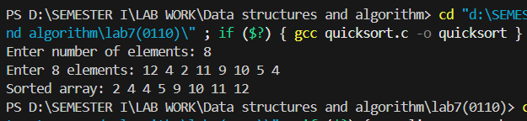

execution time for already sorted order input:- O(n^2)
execution time for unsorted input:- O(nlogn)

2. Implement Linear search algorithm.

#include <stdio.h>

int linearSearch(int arr[], int n, int key) {
for (int i = 0; i < n; i++) {
if (arr[i] == key)
return i;
}
return -1;
}

int main() {
int n, key;
printf("Enter number of elements: ");
scanf("%d", &n);

int arr[n];
printf("Enter %d elements: ", n);
for (int i = 0; i < n; i++) {
scanf("%d", &arr[i]);
}

printf("Enter element to search: ");
scanf("%d", &key);

int result = linearSearch(arr, n, key);
if (result != -1)
printf("Element %d found at index %d\n", key, result);
else
printf("Element not found\n");

return 0;
}

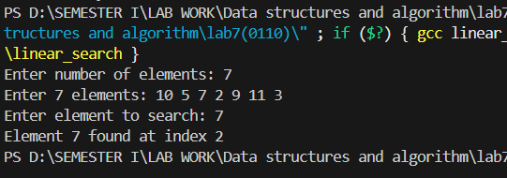

3. Implement binary search algorithm.

#include <stdio.h>

int binarySearch(int arr[], int n, int key) {
int low = 0, high = n - 1;
while (low <= high) {
int mid = (low + high) / 2;
if (arr[mid] == key)
return mid;
else if (arr[mid] < key)
low = mid + 1;
else
high = mid - 1;
}
return -1;
}

int main() {
int n, key;
printf("Enter number of elements (sorted order): ");
scanf("%d", &n);

int arr[n];
printf("Enter %d sorted elements: ", n);
for (int i = 0; i < n; i++) {
scanf("%d", &arr[i]);
}

printf("Enter element to search: ");
scanf("%d", &key);

int result = binarySearch(arr, n, key);
if (result != -1)
printf("Element %d found at index %d\n", key, result);
else
printf("Element not found\n");

return 0;
}

